We introduced two new COVID-19 data variables: monthly deaths and monthly vaccinations. Next, we will plot the five aviation-related variables (cross-country flights, local flights, number of passengers, amount of cargo, and amount of mail) alongside the monthly deaths and monthly vaccinations respectively. These plots will help visualize the trends and relationships between the aviation variables and the COVID-19 data over time.

The first part is to analyze the relationship between monthly deaths and aviation data.

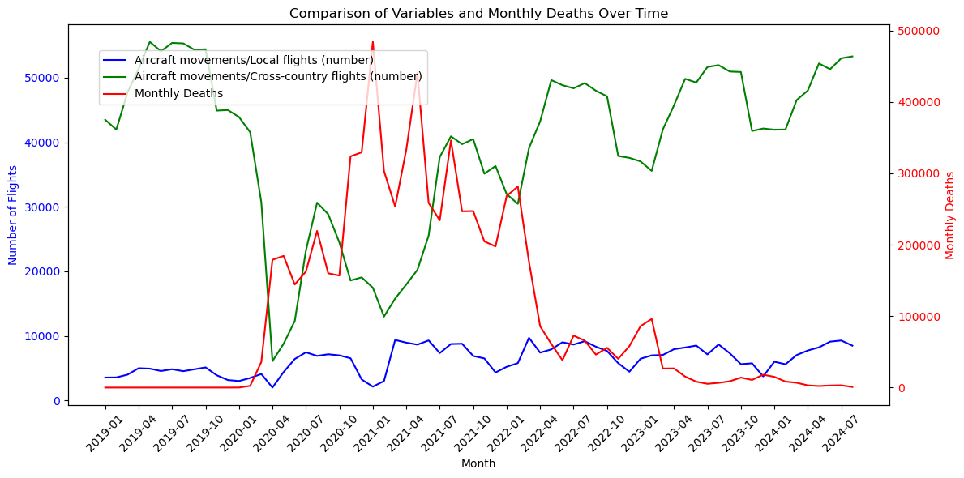

After the outbreak of the pandemic in 2020, monthly deaths surged rapidly, reaching a peak in early 2021. Subsequently, the number of deaths gradually decreased and stabilized by 2022, almost reaching zero. Local flights and cross-country flights saw significant declines during the outbreak, especially cross-country flights (green line). As monthly deaths decreased in early 2022, cross-country flight numbers began to recover. However, once the death rate approached zero, the fluctuations in flight numbers did not directly correlate with it. Thus, there is no evident direct relationship between monthly deaths and local flights or cross-country flights.

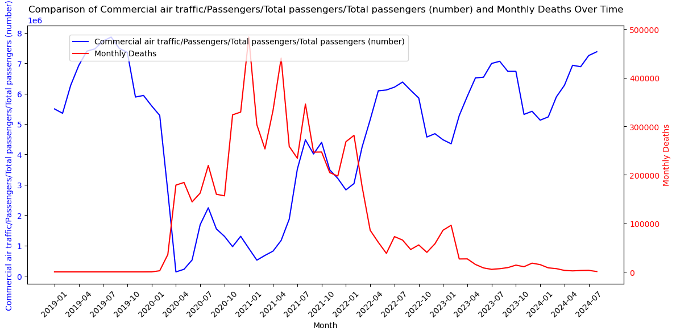

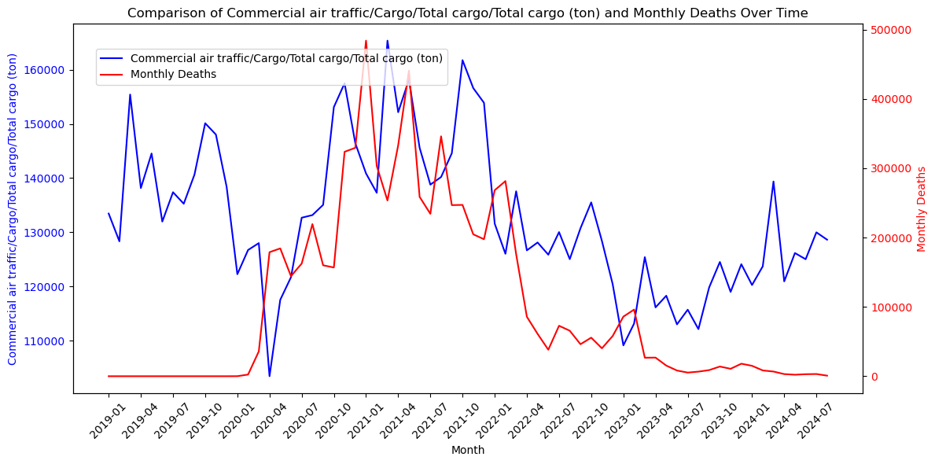

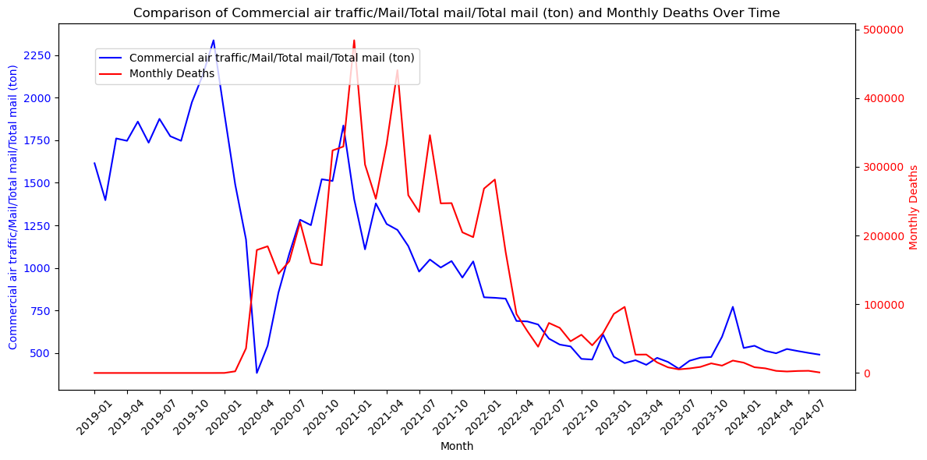

Passenger numbers dropped sharply during the initial COVID-19 outbreak and recovered as deaths decreased, but there is no strong correlation between the two in the later stages. Cargo volume showed smaller fluctuations compared to passenger numbers and remained relatively stable, with no clear relationship to monthly deaths. Mail volume showed larger fluctuations during the initial stages of the pandemic, especially when the number of deaths peaked. However, mail transport gradually returned to normal while monthly deaths dropped and remained stable. In all cases, monthly deaths did not show a clear long-term direct correlation with the aviation variables.

Next part is to analyze the relationship between monthly cumulative vaccinations and aviation data.

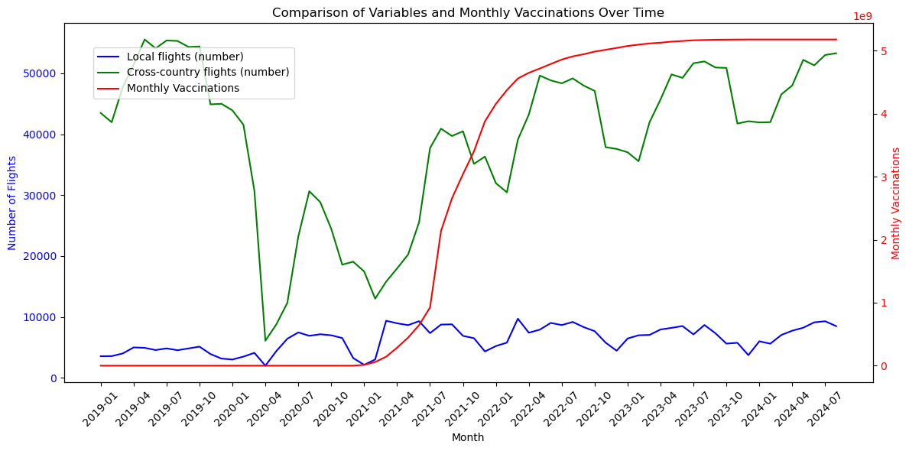

Monthly cumulative vaccinations (red line) began to rise rapidly in mid-2021 and continued steadily, reaching a stable level by 2022. This indicates the widespread rollout and coverage of vaccinations. The increase in cumulative vaccinations is somewhat correlated with the recovery of cross-country flights over time because the number of cross-country flights rose during the period of the fastest vaccination growth. However, there is no strong direct relationship. Over the entire pandemic period, cumulative vaccinations and flight numbers show no clear connection.

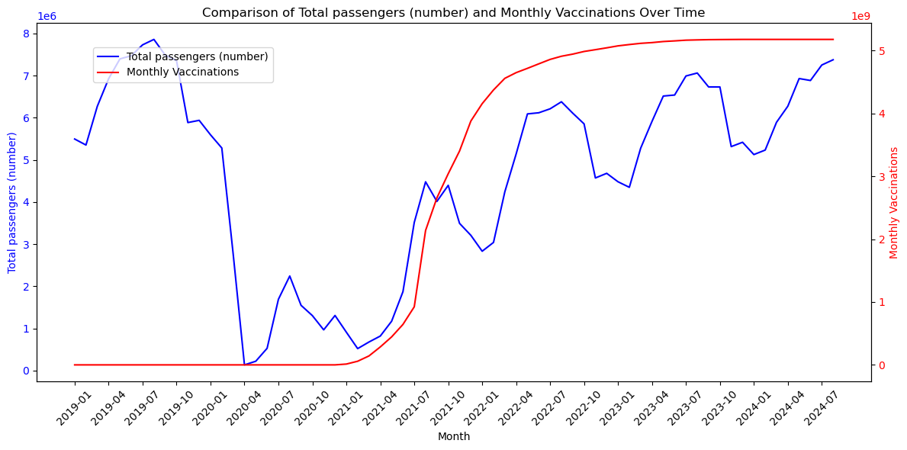

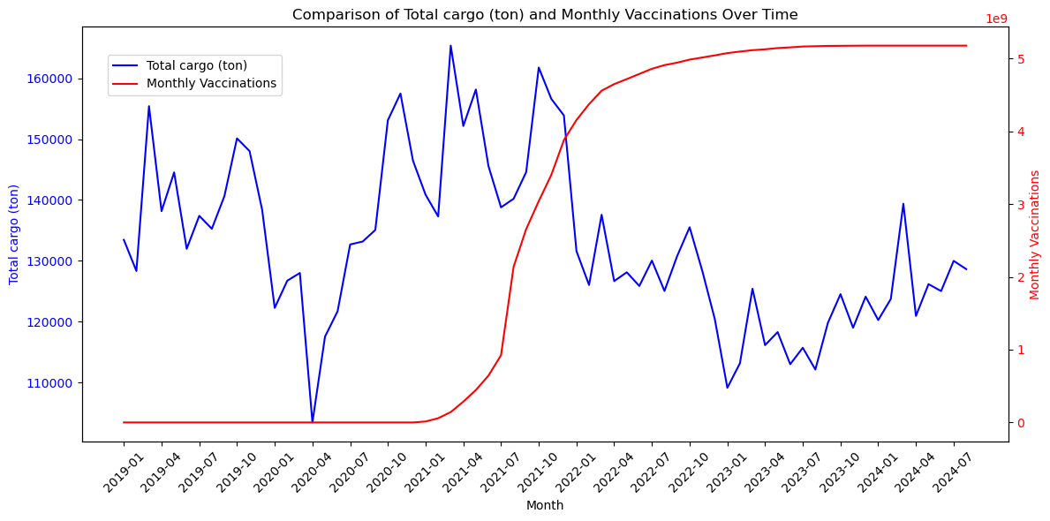

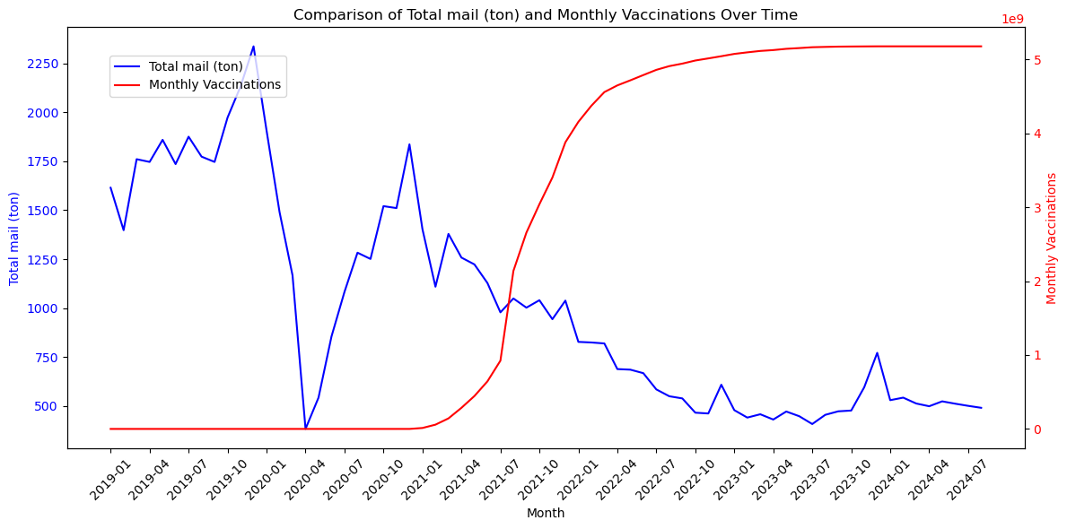

Passenger numbers gradually recovered as vaccinations increased, indicating some correlation. Although passenger recovery showed fluctuations, it generally increased during the period of rising vaccinations. Cargo volume experienced slight fluctuations early in the pandemic, but after vaccinations began, cargo volume remained relatively stable, showing minimal impact from vaccination growth. Mail volume showed some recovery after vaccination growth, the fluctuations remained significant, and no sustained recovery trend was observed. The relationship between vaccinations and mail volume is weak. Vaccinations had an impact on passenger numbers in specific period but overall, the correlation between vaccinations and aviation traffic (including passenger, cargo, and mail transport volumes) is weak.